**DAY 5 SQL ASSIGNMENT**

**-- 1.GROUP BY with WHERE - Orders by Year and Quarter**

(Display, order year, quarter, order count, avg freight cost only for those orders where freight cost > 100)

SELECT

EXTRACT(YEAR FROM order_date) AS order_year,

EXTRACT(QUARTER FROM order_date) AS order_quarter,

COUNT(order_id) AS order_count,

AVG(freight) AS avg_freight

FROM

orders

WHERE

freight > 100

GROUP BY

order_year, order_quarter

ORDER BY

order_year, order_quarter;

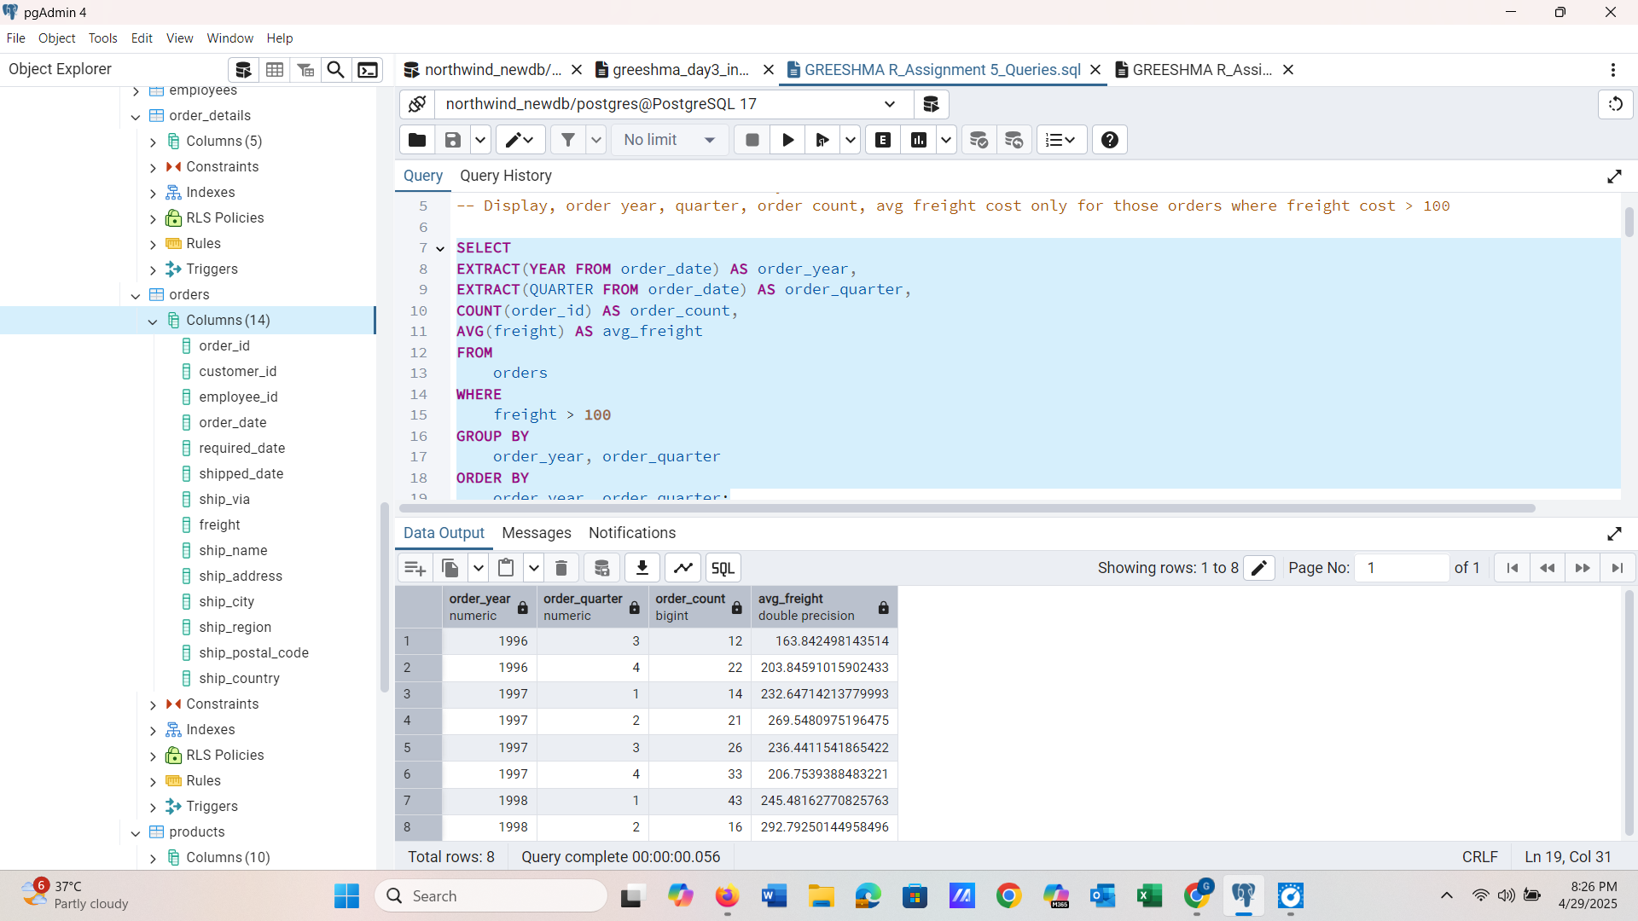

-------------------------------------------------------------------------------------------------------------------------------

**-- 2.GROUP BY with HAVING - High Volume Ship Regions**

(Display, ship region, no of orders in each region, min and max freight cost)

(Filter regions where no of orders >= 5)

SELECT

ship_region,

COUNT(order_id) AS no_of_orders,

MIN(freight) AS min_freight,

MAX(freight) AS max_freight

FROM

orders

GROUP BY

ship_region

HAVING

COUNT(order_id) >= 5;

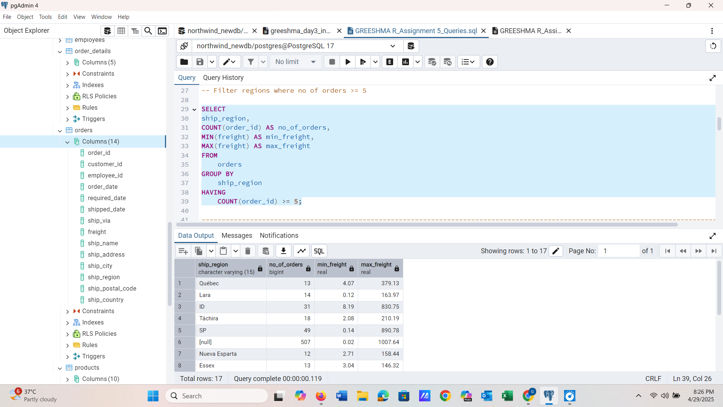

-------------------------------------------------------------------------------------------------------------------------------

**3.Get all title designations across employees and customers ( Try UNION & UNION ALL)**

-- *Using Union (removes duplicates)*

SELECT

title

FROM

employees

UNION

SELECT

contact_title

FROM

customers;

*--Union all (keeps duplicates)*

SELECT

title

FROM

employees

UNION ALL

SELECT

contact_title

FROM

customers;

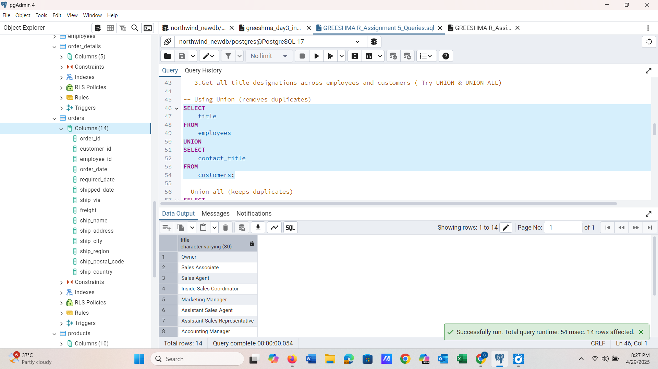 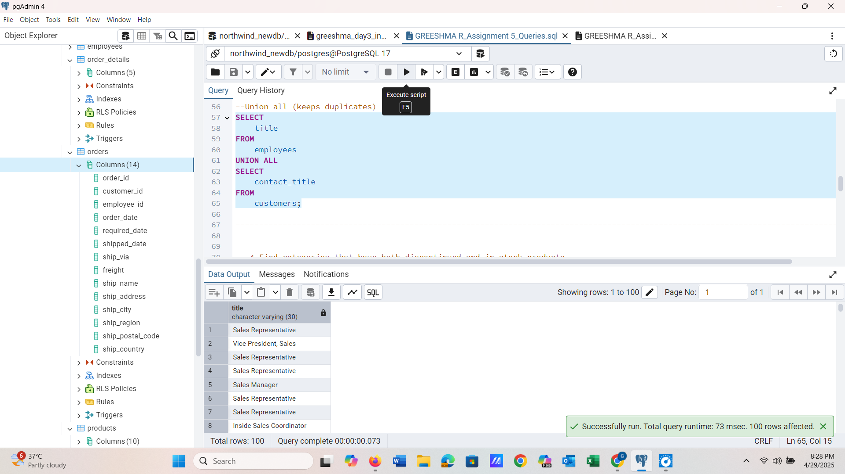

-------------------------------------------------------------------------------------------------------------------------------

**4.Find categories that have both discontinued and in-stock products**

(Display category_id, instock means units_in_stock > 0, Intersect)

*–Categories with discontinued products*

SELECT

category_id

FROM

products

WHERE

discontinued = 1

INTERSECT

*-- Categories with in-stock products*

SELECT

category_id

FROM

products

WHERE

units_in_stock > 0;

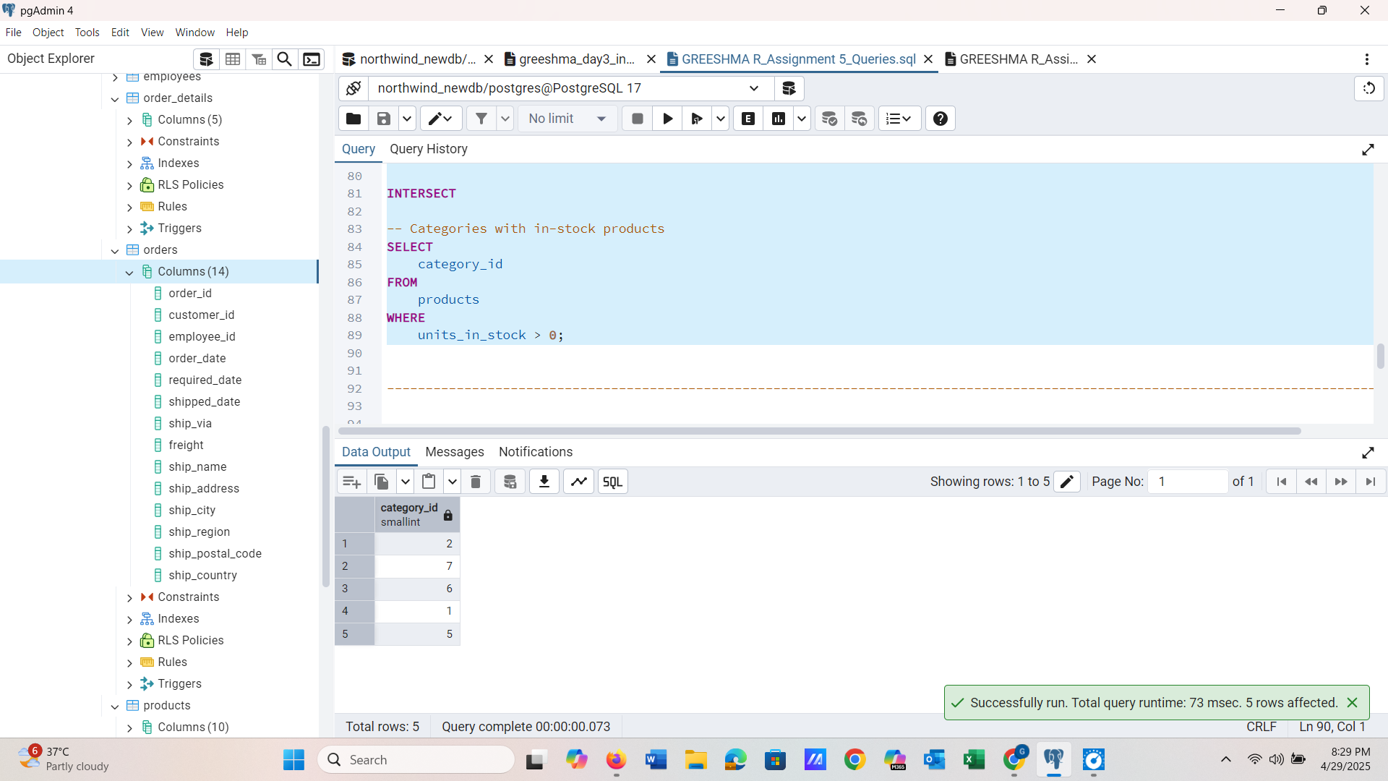

-------------------------------------------------------------------------------------------------------------------------------

**5.Find orders that have no discounted items (Display the order_id, EXCEPT)**

*-- All orders*

SELECT

order_id

FROM

order_details

EXCEPT

*-- Orders that include at least one discounted item*

SELECT

order_id

FROM

order_details

WHERE

discount > 0;

